Healthy Chocolate Crackles

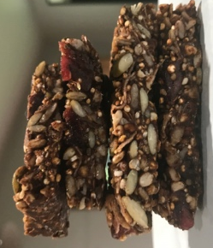

Ingredients
1 cup Raw Buckwheat
1 cup Raw White Quinoa
4 tbsp Linseeds
250g Pepitas
1 ½ cups Coconut Shavings
150g Dried Cranberries
1 ½ cups of Sunflower Seeds
4 tbsp Chia Seeds
¾ - 1 cup Honey
¾ cup Coconut Oil
4 tbsp Sesame Seeds
¾ cup Cacao Powder

Directions
Line a baking tray with baking paper.
Fry the buckwheat, sesame seeds and quinoa in hot, dry pan until fragrant (approximately 3-5 minutes).
Set aside to cool.
Gently melt oil and honey in a saucepan until combined and add cacao powder.
Mix buckwheat, sesame seeds, quinoa and remaining ingredients in with honey and oil mixture and spoon into baking tray.
Place in refrigerator until set.
Cut into slices and place in container with baking paper between layers and freeze.
Keep refrigerated when thawed.

